# **Web Development Module (HTML) - 1**

**Q1: Are the HTML tags and elements the same thing?**

**Ans**:

**HTML Tags:** HTML tags are used to define the structure and elements of a web page. They are enclosed within angle brackets (< >) and typically come in pairs: an opening tag and a closing tag.

**e.g.**

**->** <p> is the opening tag of the "paragraph" element.

**HTML Element:** HTML elements are made up of both the opening and closing tags, along with the content they enclose. An HTML element consists of the opening tag, the content, and the closing tag.

**e.g.**

**->** <p> This is a paragraph. </p> is an HTML element.

**->** <a href=<https://www.google.com>> Go to Google </a>is an HTML element.

**Q2: What are tags and attributes in HTML?**

**Ans:** HTML tags are the fundamental building blocks of an HTML document. HTML attributes provide additional information about an HTML element.

**->** HTML attributes can be used to control various aspects of elements, such as colors, sizes, links, images, and more.

**e.g.**

**->** <a> is the anchor tag used to create hyperlinks. The href attribute specifies the URL that the link should point to. The content "Go to Google" is the text that will be displayed as the link.

**Q3: What are void elements in HTML? With Example.**

**Ans:** Void elements, also known as self-closing or empty elements, are HTML elements that don't require a closing tag.

**->** These elements are used to insert specific types of content, like images or line breaks, into a web page without enclosing any content within them.

**->** Some common void elements in HTML :

1. **Image Element (<img>):** The <img> element is used to embed images in a web page.

**e.g.** <img src =”image.jpg” alt=an example image”>

1. **Link Break Element(<br>):** The <br> element is used to insert a line break within text.

**e.g.** This isthe first line. <br> This is a the secondline.

1. **Input Eliment (<input>):** The <input> element is use to create various types of form controls like text fields, checkboxes, and radio buttons.

**e.g.** <input type=”text” placeholder="Enter your name >

1. **Link Element (<link>):** The <link> element is used to link external resources like stylesheets.

**e.g.** <link rel="stylesheet" href="styles.css">

**Q4: What are HTML Entities? With Example**

**Ans:** HTML entities are special codes used to represent reserved characters and symbols in HTML.

HTML entities are special codes to represent reserved characters, symbols or special characters in HTML

**e.g.** 

**->** This is an example <strong>HTML</strong> code.

**->** &li; = < , &gt; = > , &amp; = & , &copy; = © , &reg; = ® , &deg; = °C , etc.

**Q5: What are different types of lists in HTML? With Example**.

**Ans**: We can create different types of lists to organize and structure content. There are three main types of lists: ordered lists, unordered lists, and definition lists.

1. **Order List (<ol>):** Ordered lists are used to present a list of items in a specific sequence. Each item is marked with a number or letter, indicating its order.

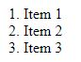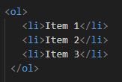**Input: Output:**

1. **Unordered List (<ul>):** Unordered lists are used to present a list of items with bullet points.

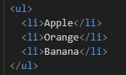**Input: Output:**

1. **Define List (<dl>):** Definition lists are used to define terms and provide their corresponding descriptions.

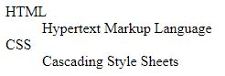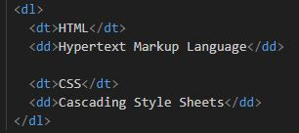**Input:** **Output:**

**Q6: What is the ‘class’ attribute in HTML? With Example**.

**Ans:** the **class** attribute is used to assign one or more class names to an HTML element.

**->** Classes are used to group elements that share similar styles or behavior.

**->** This allows to apply CSS styles or JavaScript behaviors to multiple elements at once, without needing to specify each element individually.

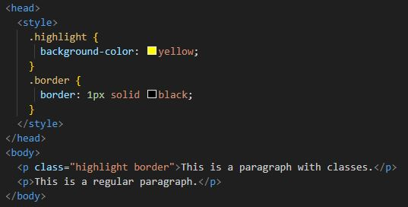**Input:**

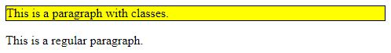**Output:**

**Q7: What is the difference between the ‘id’ attribute and the ‘class’ attribute of HTML elements? With Example**

**Ans:** Theid attribute is used to uniquely identify a single HTML element on a page. No two element on the same page should have the same id.

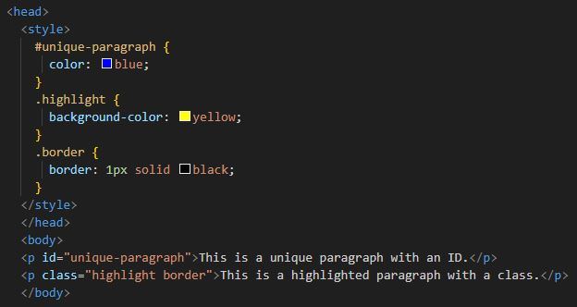**->** The class attribute is used to assign one or more class names to an element. Multiple element on the same page can share the same class.

**-> Input:**

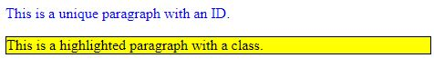

**-> Output:**

**Q8: What are the various formatting tags in HTML.**

**Ans**: These formatting tags help us define heading, emphasize text, create line breaks, and more.

1. <h1> to <h6>: Makes text heading
2. <b>: Makes text bold
3. <strong>: Makes text bold (strong)
4. <i>: Makes text italic
5. <em>: Makes text italic (emphasized)
6. <cite>: Makes text italic ()
7. <u>: Makes text underline
8. <ins>: Makes text underline (inserted)
9. <strike> or <s>: Add a line through text
10. <del>: Add a line through text
11. <sub>: Display text as subscript
12. <sup>: Display text as superscript
13. <small>: Makes text to smaller
14. <big>: Makes text to bigger
15. <code>: To display code text
16. <br>: Break line
17. <hr>: Horizontal rule
18. <mark>: Makes text marked
19. <marquee>: Makes text moving line

**Q9: How is Cell Padding different from Cell Spacing? With Example**.

**Ans:** Cell padding and cell spading are attributes used in HTML to control the spading and appearance of cells within an HTML table.

**->** Cell padding controls the space between the content of a table cell and the border of the cell.

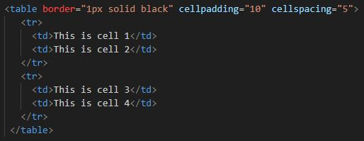**->** Cell spacing controls the space between adjacent cells in a table. It adds space between the borders of neighboring cells.

**-> Input:**

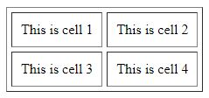

**-> Output:**

**Q10: How can we club two or more rows or columns into a single row or column in an HTML table? With Example.**

**Ans**: We have to use rowspan and colspan attributes respectively. We can give rowspan and colspan attributes to respective <th> or <td> .

**->** Use rowspan:

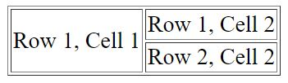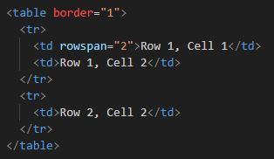Input: Output:

**->** Use colspan:

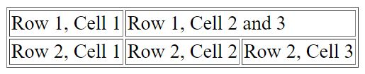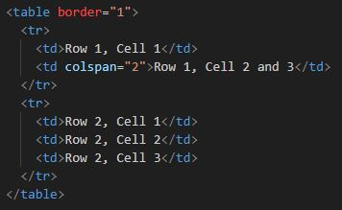Input: Output:

**Q11: What is the difference between a block-level element and an inline element?**

Ans:

**A Block-level Element:** the element will cover the full width of the page.

**An Inline Element:** the element will only cover the min-width it requires.

**->** This are Block Elements: <h1> to <h6>, <p>, <table>, <form>, <ul>, <ol>, <li>,div>,

**->** This are Inline Elements: <a>, <strong>, <em>, <span>, <img>, <input>, <br>

**12: How to create a Hyperlink in HTML? With Example**.

**Ans:** We use the <a> (anchor) element. The anchor element is used to define a link to another web page or resource.

**->** We use the href attribute to specify the URL.

**->** **e.g.**

**->** <a> = anchor, href = attribute, <https://www.google.com> = URL, Go to Google = visible text.

**Q13: What is the use of an iframe tag? With Example.**

**Ans:** The <iframe> (inline frame) tag in HTML is used to embed another web page or content within the current web page.

**->** This is commonly useful for external content, such as maps, videos, social media feeds, or other websites, into web page.

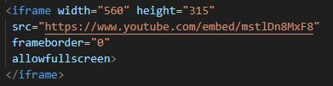**->** We can also adjust the width and height of the <iframe> using the width and height attributes:

**Q14: What is the use of a span tag? Explain with example**.

**Ans:** The <span> tag in HTML is a generic inline container that is used to apply styles or scripting to a specific portion of text or inline element.

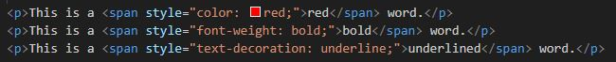**->** It doesn’t add any specific meaning or structure to the content but it provides a way to target and style that text that it wraps.

**->** Input:

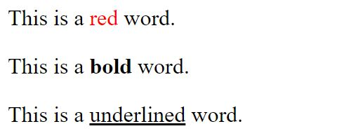

**->** Output:

**Q15: How to insert a picture into a background image of a web page? With Example.**

**Ans:** Add a background image on an HTML element, use the HTML <style> attribute.

**->** To avoid the background image from repeating itself, set the background-repeat property to no-repeat.

**->** We want the background image to cover the entire element, we can set the background-size property to cover.

**->** The entire element is always covered, set the background-attachment property to fixed.

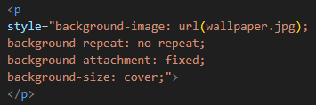**->** **e.g.**

**Q16: How are active links different from normal links?**

**Ans:** Active links and normal links are states of hyperlinks in web design.

**-> Normal links:** A normal links is also known as default link or unvisited link, are the standard appearance of links before they are interacted with.

**-> Active links:** An active links is also known as ‘hover’ links, are the state of a links when a user hover their mouse pointer over the link but hasn’t clicked it yet.

**Q17: What are the different tags to separate sections of text?**

**Ans:** In HTML, we can use various tags to structure and separate sections of text.

**-> Heading Tags (<h1> to <h6>):** Heading tags are used to define headings and subheadings

**-> Paragraph Tag (<p>):** The <p> tag is ueed to define paragraphs of text.

**-> Div Tag (<div>):** Creates division for the inner content.

**-> Section Tag (<section>):** Creates individual sections in page.

**->** The different tags are: <hr>, <ul>, <ol>, <dl>, <article>, <blockquote>,

**Q18: What is SVG?**

**Ans:** SVG stands for Scalable Vector Graphics. It's a way to create graphics, like drawings and images, using code in HTML. Unlike regular images (like JPEG or PNG), SVG images are made up of shapes, lines, and curves described by code, which makes them scalable meaning we can make them bigger or smaller without losing quality.

**->** Instead of using dots or pixels, we use instructions to tell the computer how to draw shapes and lines. This makes SVG images really clear and sharp, no matter the size. They're often used for icons, logos, charts, and other graphics on websites. We can include SVG images directly in your HTML code.

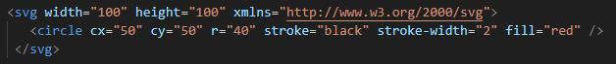**-> Input:**

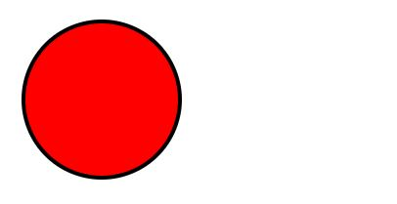

**-> Output:**

**Q19: What is difference between HTML and XHTML?**

**Ans:**

**-> Syntax:**

**HTML:** HTML has more forgiving syntax rules. Tags are not case-sensitive, and many elements can be left unclosed without causing errors in most browsers.

**XHTML:** XHTML has stricter syntax rules. Tags and attribute names are case-sensitive, and all elements must be properly closed (either with a closing tag or a self-closing syntax like <br />).

**-> Well-Formedness:**

**HTML:** Some tags and attributes can be omitted, and some invalid constructs are tolerated by browsers. This can result in inconsistent rendering across different browsers.

**XHTML:** XHTML documents must be well-formed

**Q20: What are logical and physical tags in HTML?**

**Ans:** In HTML, the terms "logical tags" and "physical tags" are often used to describe two different approaches to structuring and formatting content.

**-> Logical Tags:**

Logical tags, also known as semantic tags, are HTML elements that convey meaning about the structure and content of a webpage.

Logical tags refer to HTML elements that are used to define the structure and meaning of the content, regardless of how it's presented visually.

**-> Examples of logical tags:**

<h1> to <h6>: Headings that define the hierarchy of the content.

<p>: Paragraphs that separate blocks of text.

<ul> and <ol>: Unordered and ordered lists for structuring content.

<table>: Defines a table structure.

**-> Physical Tags:**

Physical tags, sometimes referred to as "formatting tags," are used to style and format the presentation of content.

Physical tags, sometimes referred to as presentational tags, are HTML elements that are primarily used for formatting and styling purposes.

**->**  **Examples of physical tags :**

<b>: Renders text in bold.

<i>: Renders text in italics.

<u>: Renders text with an underline.

<font>: Used to change font size and color.